T E X A S M A I N S T R E E T
DESIGN OPTIONS

BUILDING: 703 Liberty, Quality Cafe
CITY: Beaumont, Texas

DATE: December 12, 2005
BY: Sarah Jane Blankenship

________________________________________________________________________

These renderings are offered as part of the Design Assistance Program through the Texas Main Street Office and may not be used for regulatory approval, permit, or construction.

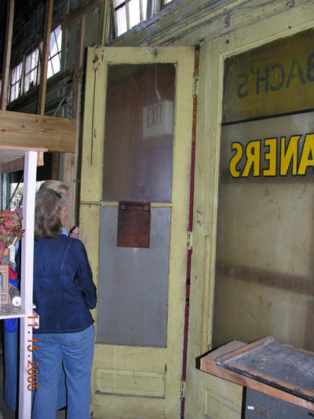
Main Street Staff, Wayne Bell, met with the Beaumont Main Street Program about the Quality Café building at 703 Liberty. Photographs of the interior of the building taken during the site visit show the proportions of the historic doors, windows and their relationship to the transom windows. These photographs and notes allowed for an appropriate configuration of the front façade that has been shown in the attached renderings. We suggest that the material seen in these photographs, wood, be used for the entire façade as it will match the historic fabric and be the most fitting choice for the façade. If expense is a concern for replacement of any existing metal doors or windows, an alternative choice for the time being would be to clad the front of the metal with wood. This alternative option would also achieve the goal of a unified appearance of the front façade.

In the renderings, the canopy is shown repaired with the tie-rods re-anchored to their original/historic position. We suggest a fresh paint job to both the trim and the base color of the building. Two types of garage doors have been suggested; one opens overhead, the other opens to the sides.
______________________________________________________________________________________
If there are further comments or questions or changes desired, please contact

Sarah Jane Blankenship at (512) 463-0963 or Wayne Bell at (512) 463-0961.

